Solar Year (Tropical Year)
# Source: AI Source: Provided by: [Data Path: Persons Table -> ID Column: 1, Name_En Column: Motasem Essam] -> From: [ChatGPT] on [7/17/2026]
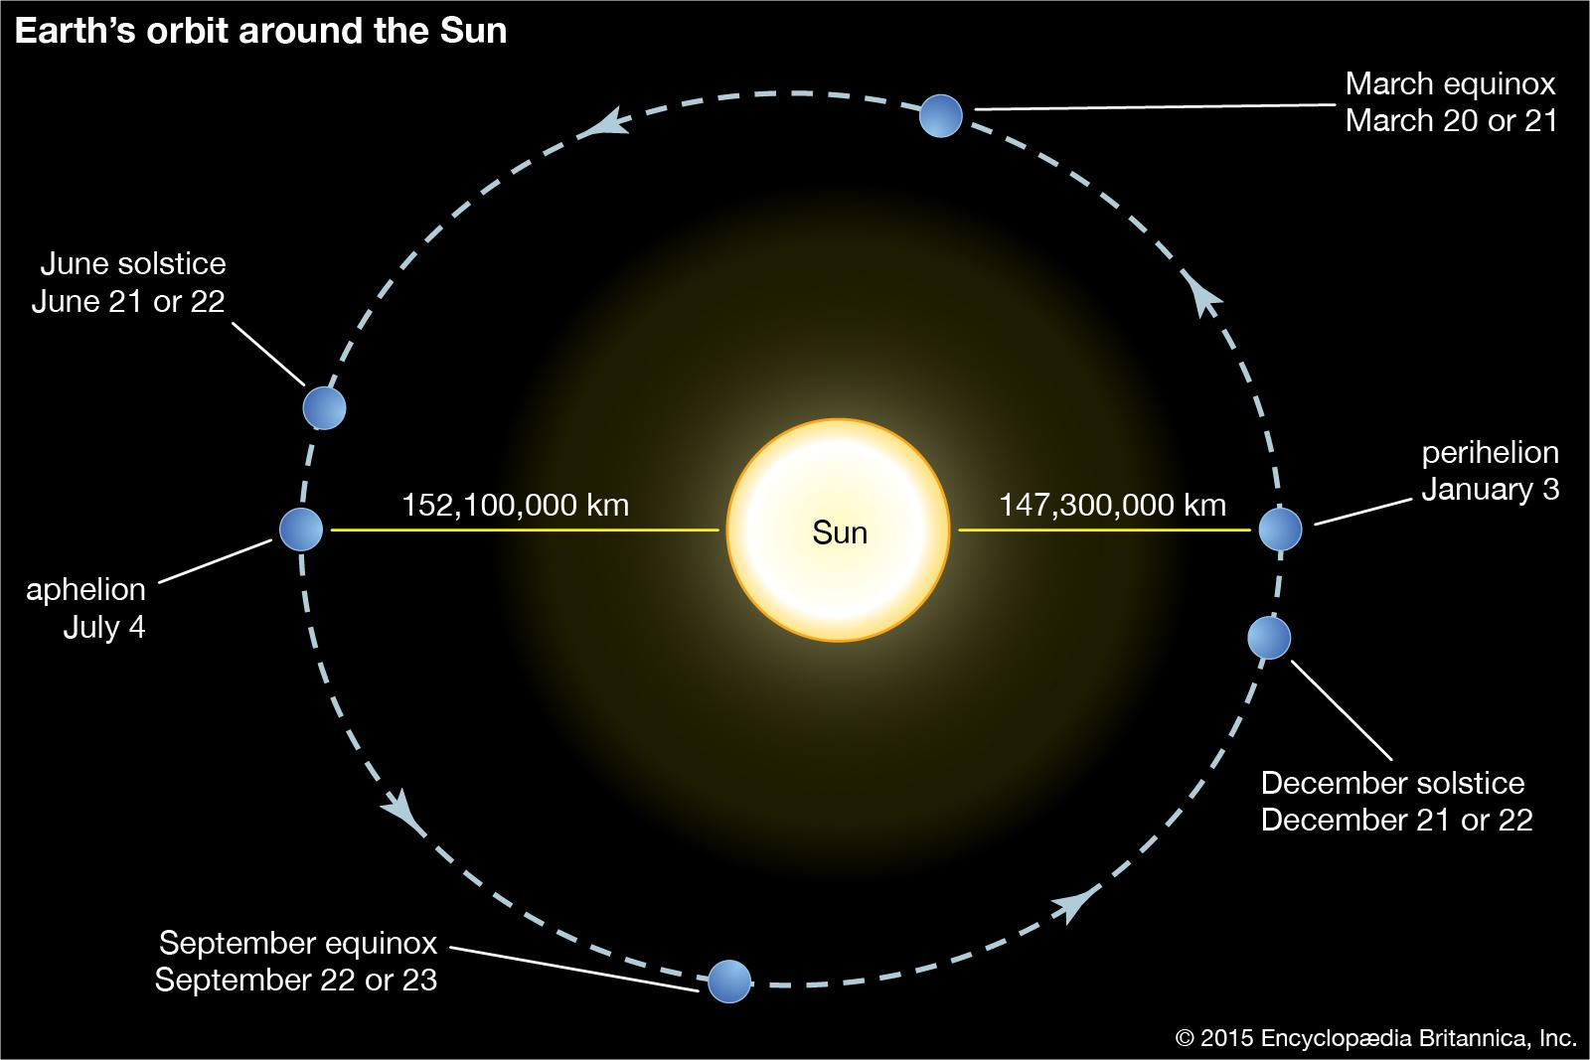
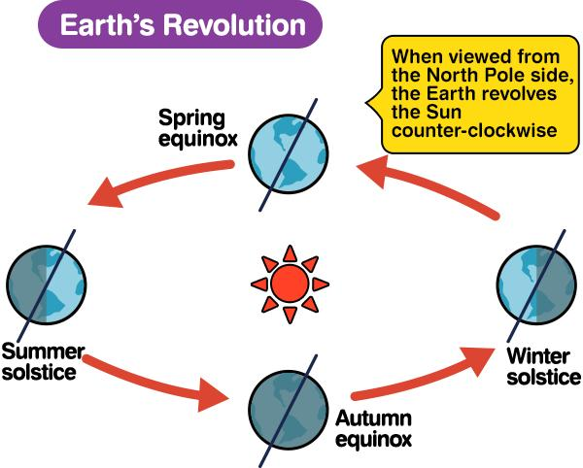
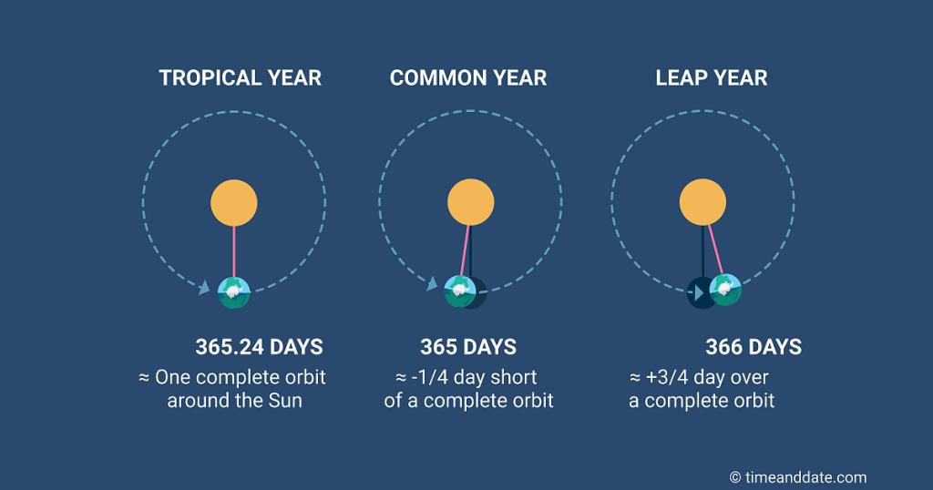
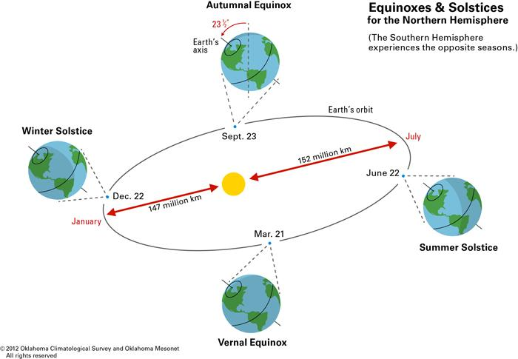
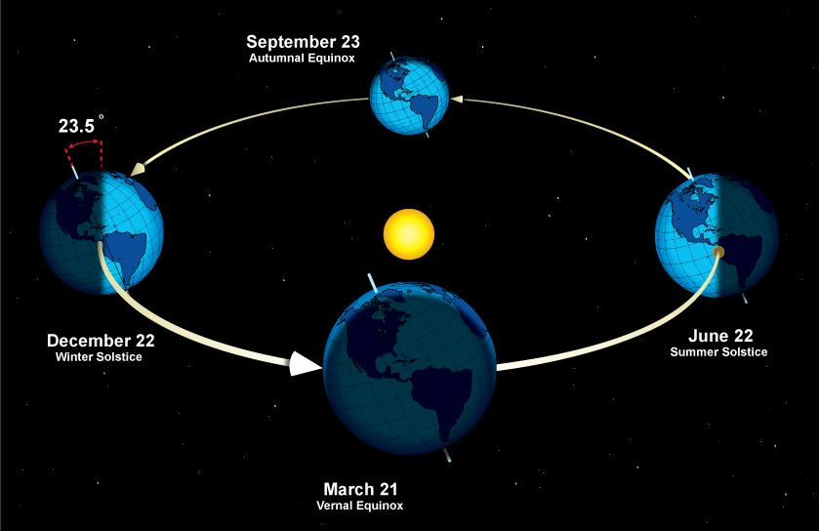
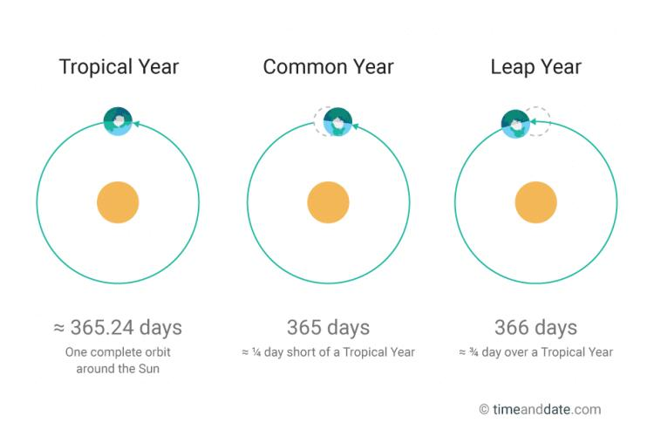
A Solar Year, also called the Tropical Year, is the time required for the Earth to complete one orbit around the Sun relative to the cycle of the seasons. It is the standard astronomical year used for modern civil calendars because it keeps the calendar synchronized with spring, summer, autumn, and winter.
The average length of a tropical year is approximately:
$$365.2422\text{ days}$$
This value is the basis for the Gregorian Calendar and explains why leap years are necessary.

Definition
# Source: AI Source: Provided by: [Data Path: Persons Table -> ID Column: 1, Name_En Column: Motasem Essam] -> From: [ChatGPT] on [7/17/2026]
A Solar Year (Tropical Year) is the average time required for the Earth to complete one revolution around the Sun and return to the same position relative to the seasons, such as from one spring equinox to the next.

Astronomical Basis
# Source: AI Source: Provided by: [Data Path: Persons Table -> ID Column: 1, Name_En Column: Motasem Essam] -> From: [ChatGPT] on [7/17/2026]
A tropical year is measured by the Earth's orbit around the Sun and the repeating cycle of the equinoxes and solstices.
For example:
- Spring Equinox → next Spring Equinox
- Summer Solstice → next Summer Solstice
This keeps the calendar aligned with the Earth's seasonal cycle.

Average Length
# Source: AI Source: Provided by: [Data Path: Persons Table -> ID Column: 1, Name_En Column: Motasem Essam] -> From: [ChatGPT] on [7/17/2026]
The average length of one tropical year is:
$$365.2422\text{ days}$$
Equivalent to approximately:
- 365 days
- 5 hours
- 48 minutes
- 46 seconds

Why Is It Not Exactly 365 Days?
# Source: AI Source: Provided by: [Data Path: Persons Table -> ID Column: 1, Name_En Column: Motasem Essam] -> From: [ChatGPT] on [7/17/2026]
The Earth's orbit does not take exactly 365 days.
Each year includes an additional:
$$0.2422\text{ day}$$
If this extra time were ignored:
- The calendar would slowly drift.
- The seasons would gradually occur on different calendar dates.

Leap Year Adjustment
# Source: AI Source: Provided by: [Data Path: Persons Table -> ID Column: 1, Name_En Column: Motasem Essam] -> From: [ChatGPT] on [7/17/2026]
To compensate for the extra 0.2422 day each year, the Gregorian Calendar adds an extra day approximately every four years.
Gregorian Leap-Year Rule
A year is a leap year if:
- It is divisible by 4,
except:
- Years divisible by 100 are not leap years,
unless:
- They are also divisible by 400.
This keeps the average calendar year very close to the tropical year.

Relationship to Other Time Units
# Source: AI Source: Provided by: [Data Path: Persons Table -> ID Column: 1, Name_En Column: Motasem Essam] -> From: [ChatGPT] on [7/17/2026]
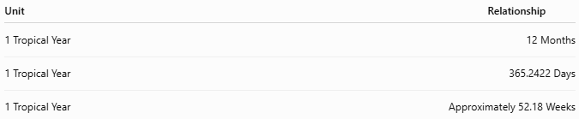
Unit | Relationship
1 Tropical Year | 12 Months
1 Tropical Year | 365.2422 Days
1 Tropical Year | Approximately 52.18 Weeks

Importance
# Source: AI Source: Provided by: [Data Path: Persons Table -> ID Column: 1, Name_En Column: Motasem Essam] -> From: [ChatGPT] on [7/17/2026]
The tropical year is important because it:
- Determines the cycle of the seasons.
- Forms the basis of modern civil calendars.
- Supports agriculture.
- Maintains seasonal festivals.
- Enables accurate long-term timekeeping.

Applications
# Source: AI Source: Provided by: [Data Path: Persons Table -> ID Column: 1, Name_En Column: Motasem Essam] -> From: [ChatGPT] on [7/17/2026]
The tropical year is used in:
- Gregorian Calendar
- Solar calendars
- Astronomy
- Climate studies
- Agriculture
- Navigation
- Scientific research

Solar Year vs. Calendar Year
# Source: AI Source: Provided by: [Data Path: Persons Table -> ID Column: 1, Name_En Column: Motasem Essam] -> From: [ChatGPT] on [7/17/2026]
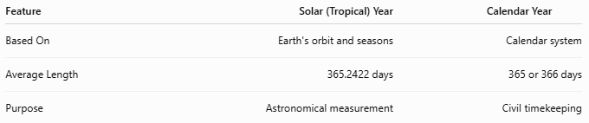
Feature | Solar (Tropical) Year | Calendar Year
Based On | Earth's orbit and seasons | Calendar system
Average Length | 365.2422 days | 365 or 366 days
Purpose | Astronomical measurement | Civil timekeeping

Solar Year vs. Sidereal Year
# Source: AI Source: Provided by: [Data Path: Persons Table -> ID Column: 1, Name_En Column: Motasem Essam] -> From: [ChatGPT] on [7/17/2026]
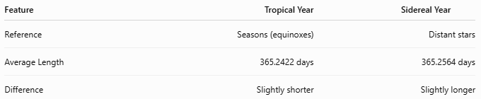
Feature | Tropical Year | Sidereal Year
Reference | Seasons (equinoxes) | Distant stars
Average Length | 365.2422 days | 365.2564 days
Difference | Slightly shorter | Slightly longer
The tropical year is shorter because of the precession of the Earth's axis, which causes the equinoxes to shift slightly each year.

Advantages
# Source: AI Source: Provided by: [Data Path: Persons Table -> ID Column: 1, Name_En Column: Motasem Essam] -> From: [ChatGPT] on [7/17/2026]
Using the tropical year:
- Keeps calendars synchronized with the seasons.
- Supports agriculture and climate-based planning.
- Provides a stable framework for civil calendars.
- Improves long-term calendar accuracy.

Common Mistakes
# Source: AI Source: Provided by: [Data Path: Persons Table -> ID Column: 1, Name_En Column: Motasem Essam] -> From: [ChatGPT] on [7/17/2026]
- Confusing a solar year with a calendar year.
- Confusing a tropical year with a sidereal year.
- Assuming the Earth takes exactly 365 days to orbit the Sun.
- Believing leap years are arbitrary rather than necessary to match the tropical year.

Interesting Facts
# Source: AI Source: Provided by: [Data Path: Persons Table -> ID Column: 1, Name_En Column: Motasem Essam] -> From: [ChatGPT] on [7/17/2026]
- The Gregorian Calendar has an average year length of:
$$365.2425\text{ days}$$
- This differs from the tropical year by only about 26 seconds per year, making it one of the most accurate civil calendar systems ever developed.

Key Points
# Source: AI Source: Provided by: [Data Path: Persons Table -> ID Column: 1, Name_En Column: Motasem Essam] -> From: [ChatGPT] on [7/17/2026]
Key Points
- A Solar Year is also called the Tropical Year.
- It measures one complete seasonal cycle.
- Average length:
$$365.2422\text{ days}$$
- It is the basis for:
  - Gregorian Calendar
  - Most modern solar calendars
- Leap years keep the calendar aligned with the tropical year and the seasons.

Conclusion
# Source: AI Source: Provided by: [Data Path: Persons Table -> ID Column: 1, Name_En Column: Motasem Essam] -> From: [ChatGPT] on [7/17/2026]
The Solar Year (Tropical Year) is the astronomical period required for the Earth to complete one orbit around the Sun relative to the cycle of the seasons. Lasting approximately 365.2422 days, it provides the foundation for modern solar calendars by ensuring that seasonal events, such as the equinoxes and solstices, occur at nearly the same calendar dates each year. The introduction of leap years allows civil calendars, especially the Gregorian Calendar, to remain closely synchronized with the tropical year, making it the most important reference for modern timekeeping and seasonal organization.

